

Mini Project Report: 07
Master of Computer Application –
Semester I

Subject: Front-End Frameworks and Technologies

Topic: Resume Website with CSS Styling
By
Name: ARBAB SUHAIL
Registration No: PROV/ASAC/MCA/7/26/082
Faculty Name: VEERA RAGHAV K
Faculty Signature:________________

Department of Computer Application
Alliance University
Chandapura – Anekal Main Road, Anekal
Bengaluru – 562 106

August 2026

INDEX
SL NO | NAME OF THE CONTENT | PAGE NO
1 | INTRODCUTION | 3
2 | INPUT CODE | 4
3 | CODE OUTPUT | 10
4 | CONCLUSION | 11

INTRODUCTION

“My mini project is a Resume Website developed using HTML and CSS. HTML is used to create the structure of the resume, such as personal details, education, skills, projects and contact information. CSS is used to style the website and make it clean, attractive and easy to read.”

INPUT CODE

<!DOCTYPE html>
<html>
<head>
<title>Arbab Suhail - Resume</title>
<style>
* {
box-sizing: border-box;
}
body {
font-family: Arial, sans-serif;
background: #eeeeee;
margin: 0;
padding: 30px;
}
.resume {
max-width: 850px;
margin: auto;
background: white;
box-shadow: 0 0 15px #999;
}
.header {
background: #17cc44;
color: white;
text-align: center;
padding: 30px;
}
.header h1 {
margin: 0;
font-size: 38px;
}
.header p {
font-size: 18px;
margin: 10px 0;
}

.contact {
font-size: 14px;
margin-top: 15px;
}

.section {
padding: 20px 35px;
border-bottom: 1px solid #ddd;
}

.section h2 {
color: #11df4f;
border-bottom: 2px solid #11ca3f;
padding-bottom: 5px;
}

.card {
background: #f5f7f9;
padding: 15px;
margin: 10px 0;
border-left: 4px solid #16e76d;
}

.card h3 {
margin-top: 0;
color: #333;
}

.skills span {
display: inline-block;
background: #1ed30e;
color: white;
padding: 8px 14px;
margin: 5px;
border-radius: 20px;
}

ul {
line-height: 1.8;
}

.download {
text-align: center;
padding: 25px;
}

.download a {
background: #f00909;
color: white;
text-decoration: none;
padding: 12px 25px;
border-radius: 5px;
display: inline-block;
}

.download a:hover {
background: #07d623;
}

.footer {
text-align: center;
background: #0ad325;
color: white;
padding: 15px;
}

@media (max-width: 600px) {
body {
padding: 10px;
}
.header h1 {
font-size: 30px;
}
.section {
padding: 18px;
}
.contact {
line-height: 1.8;
}
}
</style>
</head>

<body>
<div class="resume">
<!-- Profile Section -->
<div class="header">
<h1>Arbab Suhail</h1>
<p>MCA - Data Science Student</p>
<div class="contact">
Email: arbabsuhail004@gmail.com |
Location: Lucknow, Uttar Pradesh
</div>
</div>
<!-- About Me -->
<div class="section">
<h2>About Me</h2>
<p>
I am a motivated MCA Data Science student interested in
programming, web development and data science. I enjoy
learning new technologies and improving my technical skills.
</p>
</div>
<!-- Education -->
<div class="section">
<h2>Education</h2>
<div class="card">
<h3>Master of Computer Applications (MCA)</h3>
<p>Data Science - Alliance University</p>
</div>
<div class="card">
<h3>Bachelor of Computer Applications (BCA)</h3>
<p>MJPR University</p>
</div>
</div>
<!-- Skills -->
<div class="section">
<h2>Technical Skills</h2>
<div class="skills">
<span>HTML</span>
<span>CSS</span>
<span>Python</span>
<span>SQL</span>
<span>JavaScript</span>
<span>Data Science</span>
</div>
</div>
<!-- Projects -->
<div class="section">
<h2>Projects</h2>
<div class="card">
<h3>Medical Store Management System</h3>
<p>
A project for managing patient details, medicine
information, expiry details and billing.
</p>
</div>
<div class="card">
<h3>Resume Website</h3>
<p>
A personal resume website created using HTML and
CSS styling.
</p>
</div>
</div>
<!-- Certifications -->
<div class="section">
<h2>Certifications</h2>
<div class="card">
<h3>Web Development Certification</h3>
<p>HTML, CSS and basic JavaScript</p>
</div>
<div class="card">
<h3>Python Programming Certification</h3>
<p>Basics of Python Programming</p>
</div>
</div>
<!-- Internship -->
<div class="section">
<h2>Internship</h2>
<div class="card">
<h3>Web Development Intern</h3>
<p>
Worked on basic web development tasks using HTML,
CSS and JavaScript and gained practical development
experience.
</p>
</div>
</div>
<!-- Achievements -->
<div class="section">
<h2>Achievements</h2>
<ul>
<li>Completed academic projects in web development.</li>
<li>Developed programming skills using Python.</li>
<li>Participated in technical and academic activities.</li>
<li>Continuously learning new technologies.</li>
</ul>
</div>
<!-- Hobbies -->
<div class="section">
<h2>Hobbies & Interests</h2>
<ul>
<li>Playing Football</li>
<li>Listening to Music</li>
<li>Programming</li>
<li>Learning New Technologies</li>
</ul>
</div>
<!-- Contact -->
<div class="section">
<h2>Contact</h2>
<p><b>Email:</b> arbabsuhail004@gmail.com</p>
<p><b>Location:</b> Lucknow, Uttar Pradesh</p>
<p><b>Career Interest:</b> Web Development & Data Science</p>
</div>
<!-- Download Resume -->
<div class="download">
<a href="resume.pdf" download>Download Resume</a>
</div>
<!-- Footer -->
<div class="footer">
© 2026 Arbab Suhail | Resume Website
</div>
</div
</body>
</html>

CODE OUTPUT

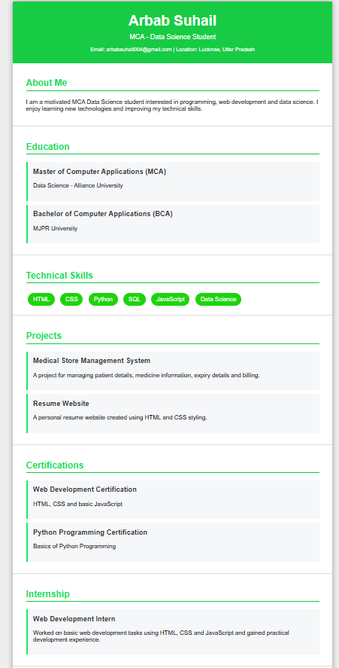
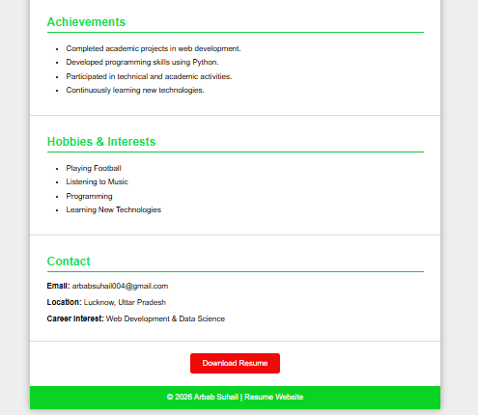

CONCLUSION
“In conclusion, this project helped me understand the basics of HTML and CSS. I learned how to create a structured resume webpage and style it using CSS. This project also improved my understanding of webpage design and basic frontend development.”

